**Cover Page**

**CSCI 2272 - Computer Organization and Lab**

**Lab 7**

**Student 1 Name and BC Email: Grace Wagner - wagnerge@bc.edu**

**Student 2 Name and BC Email: Jonathan Nushi - nushi@bc.edu**

## Circuit 1

## Design

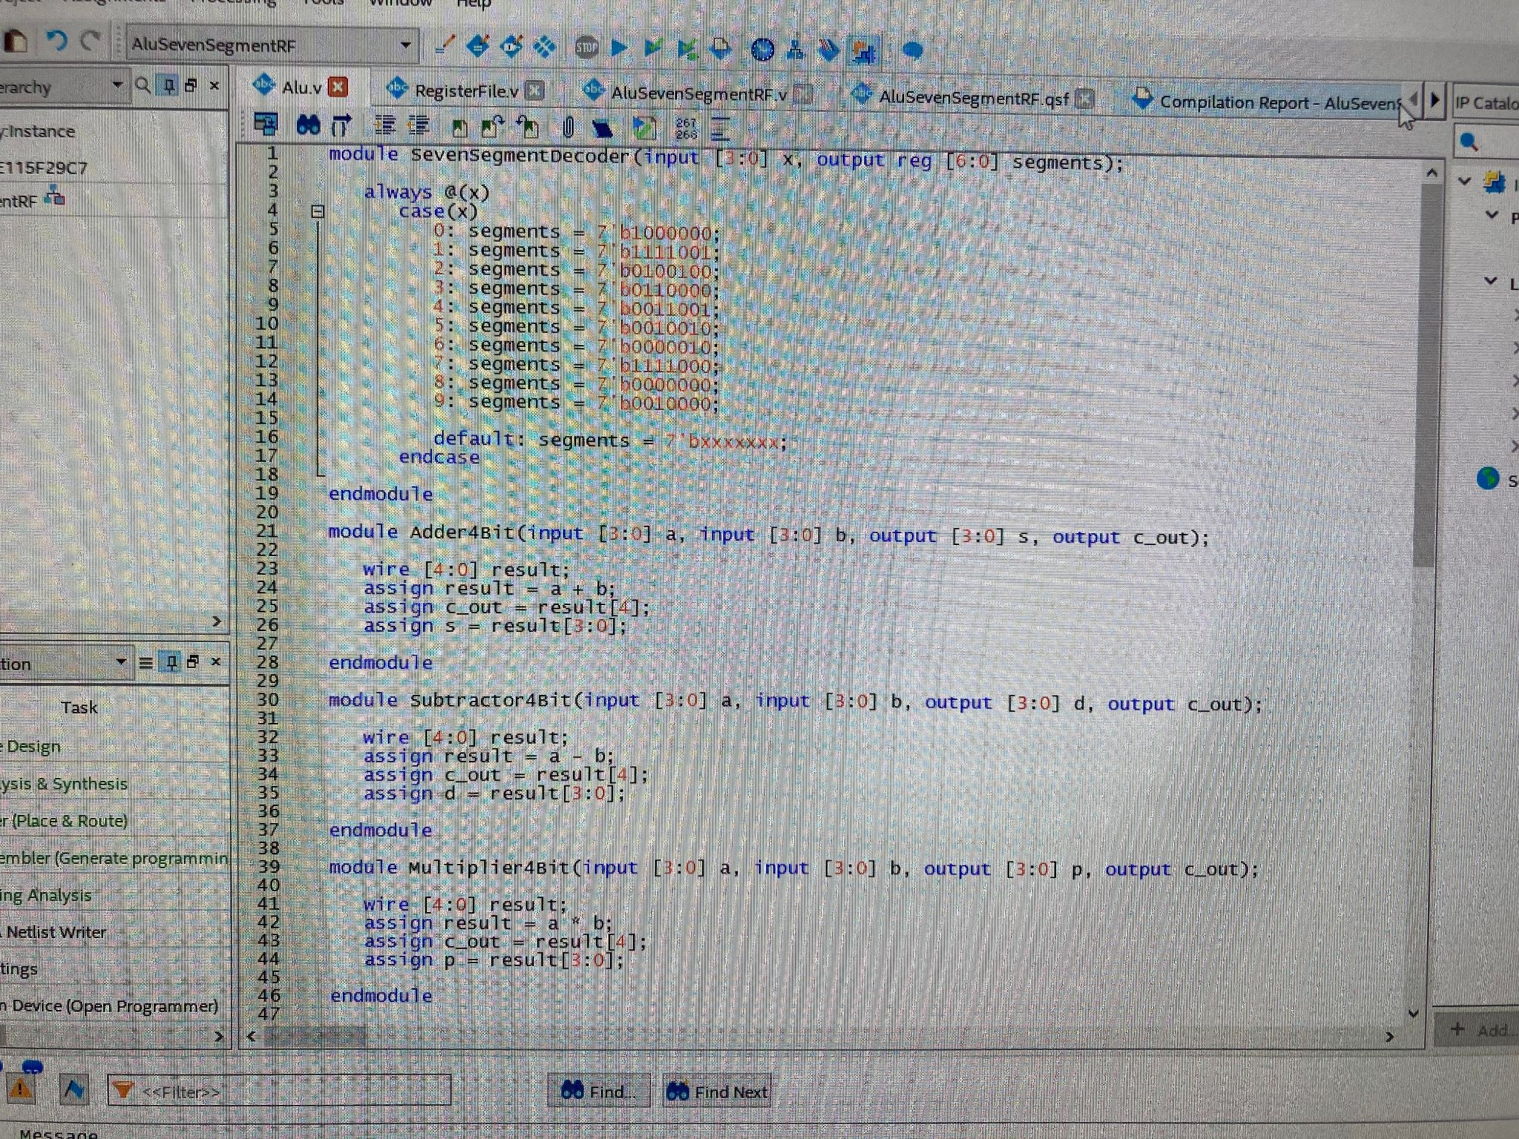

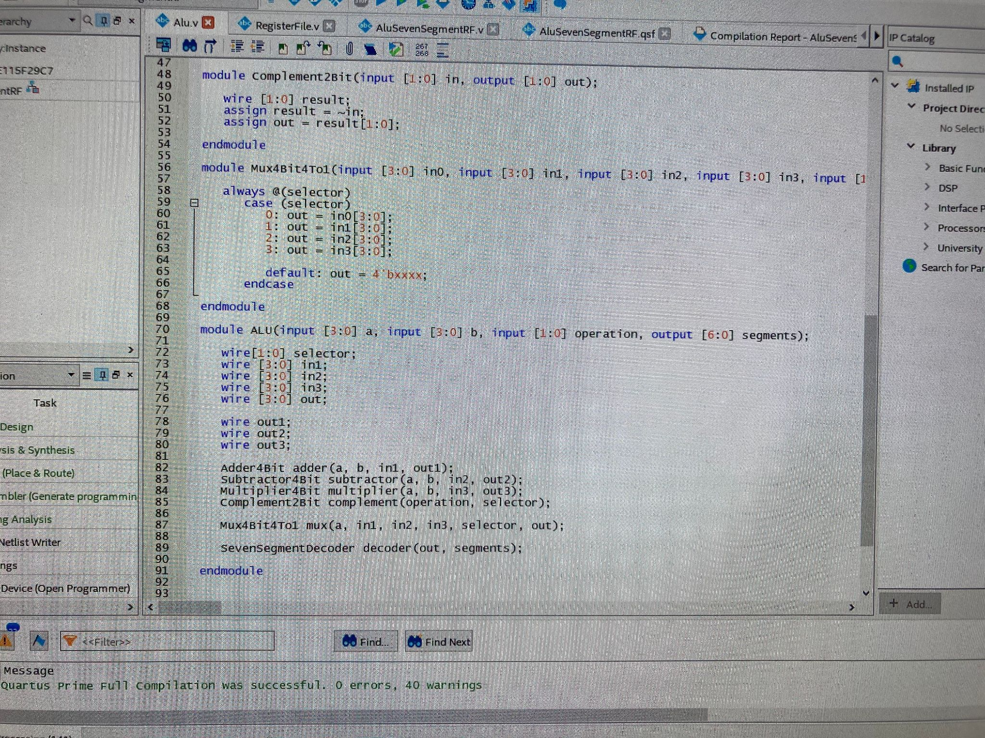

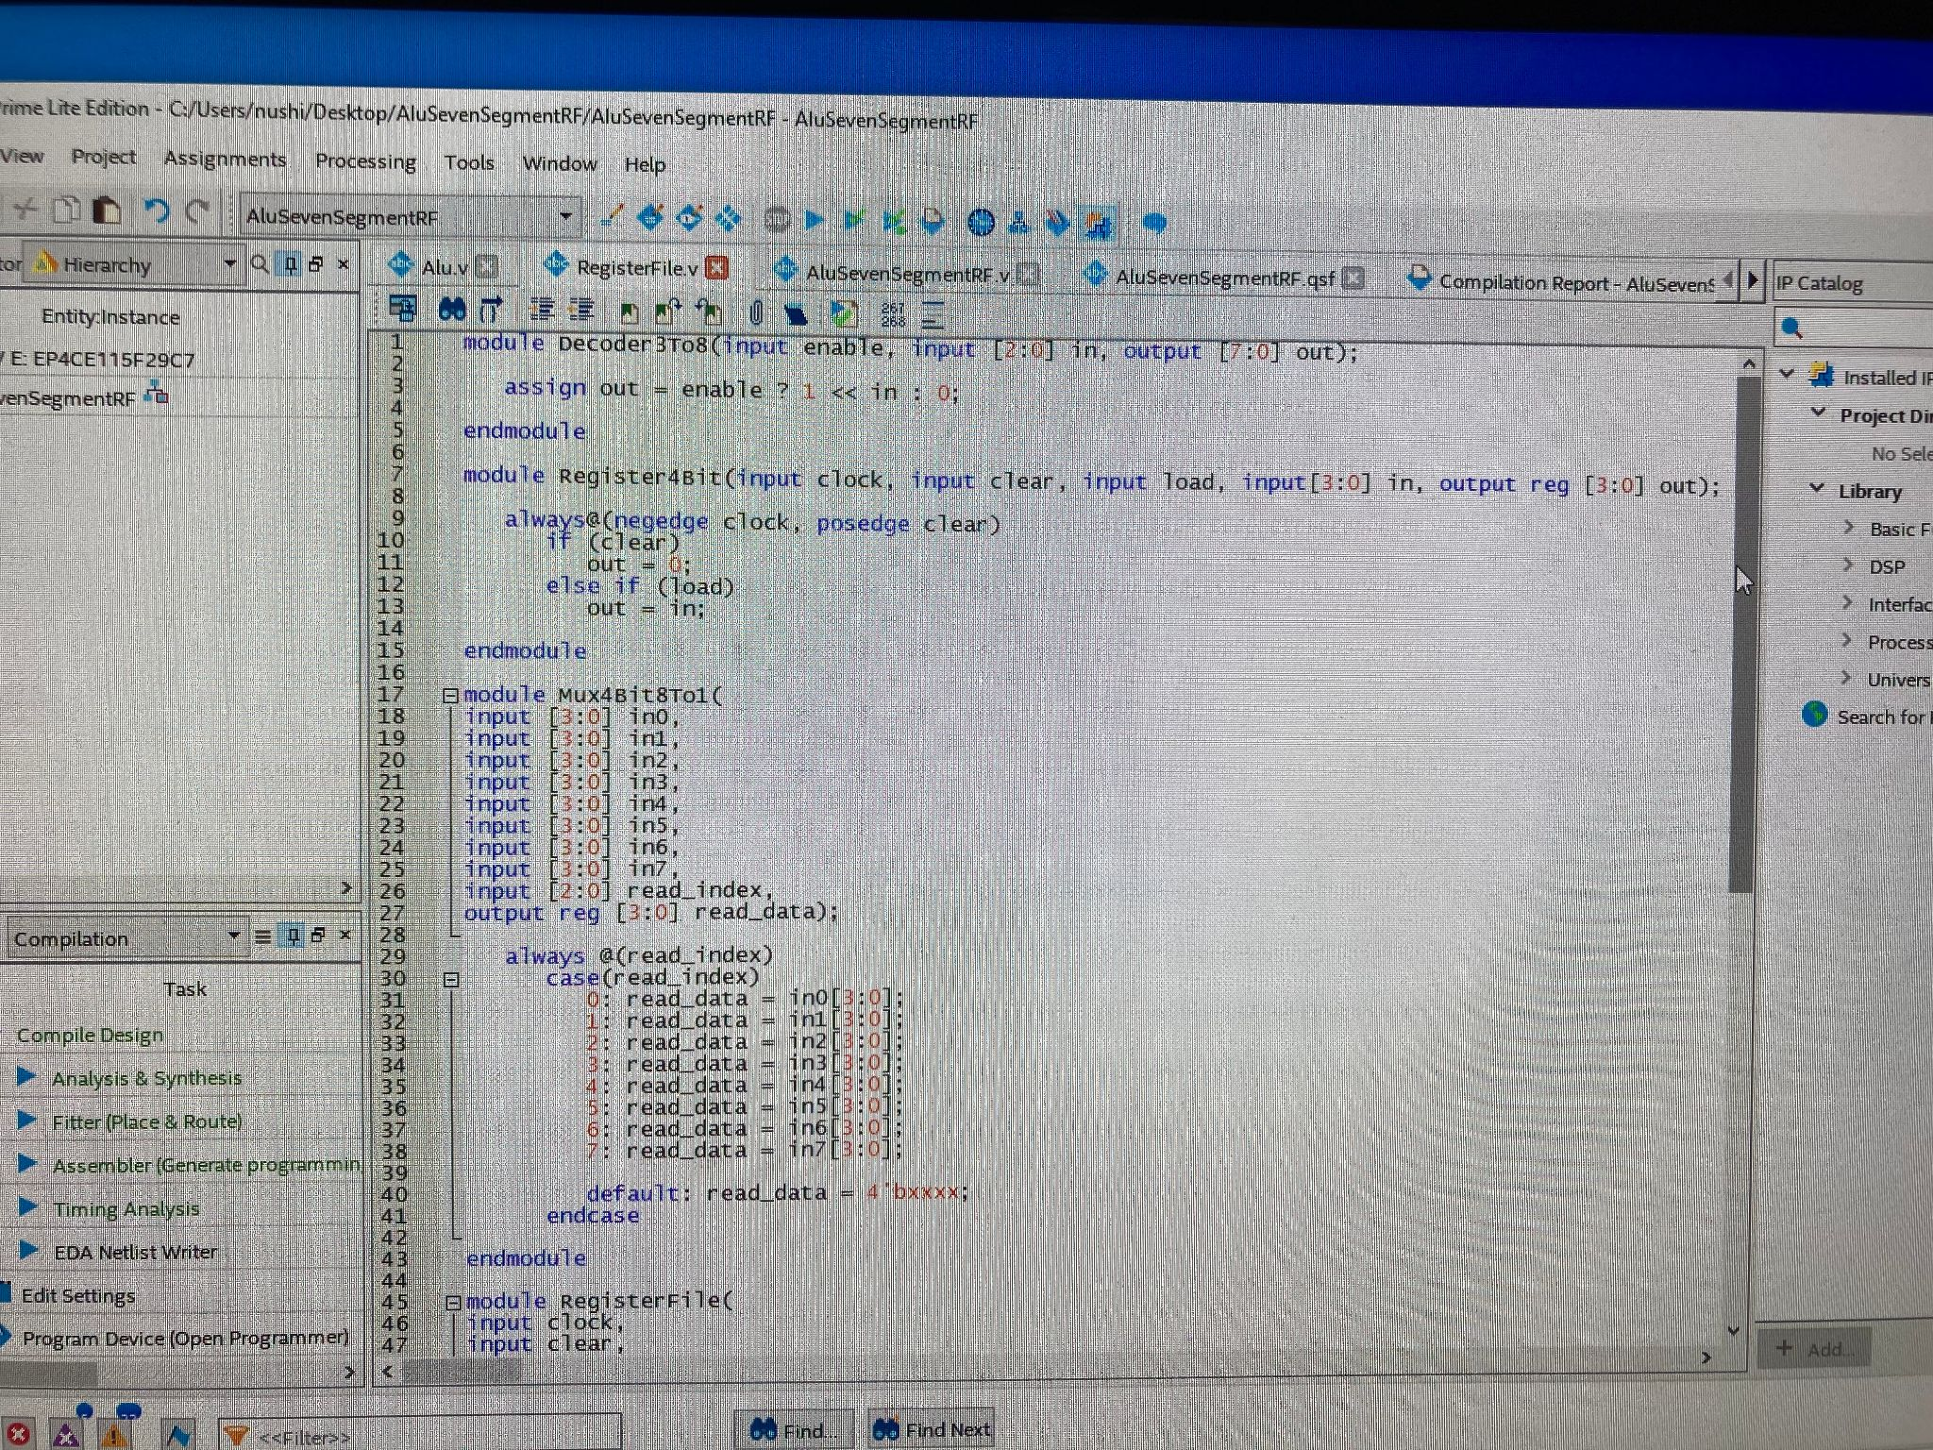

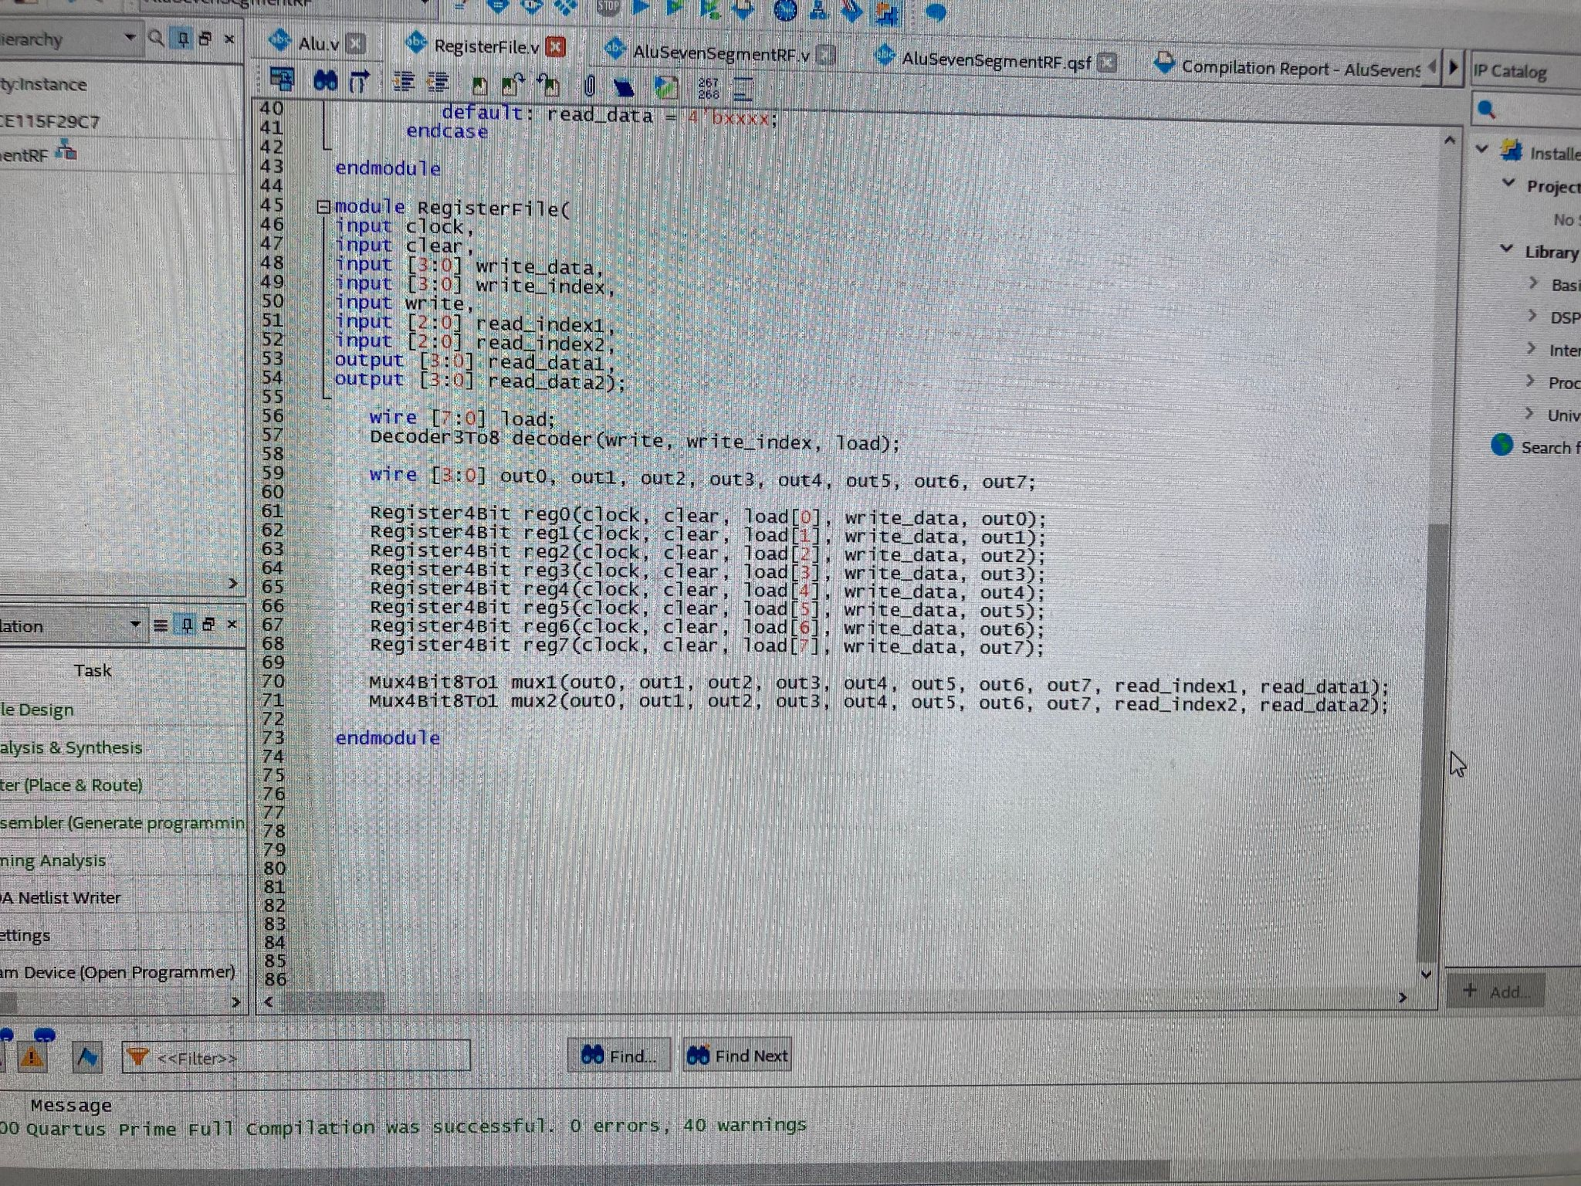

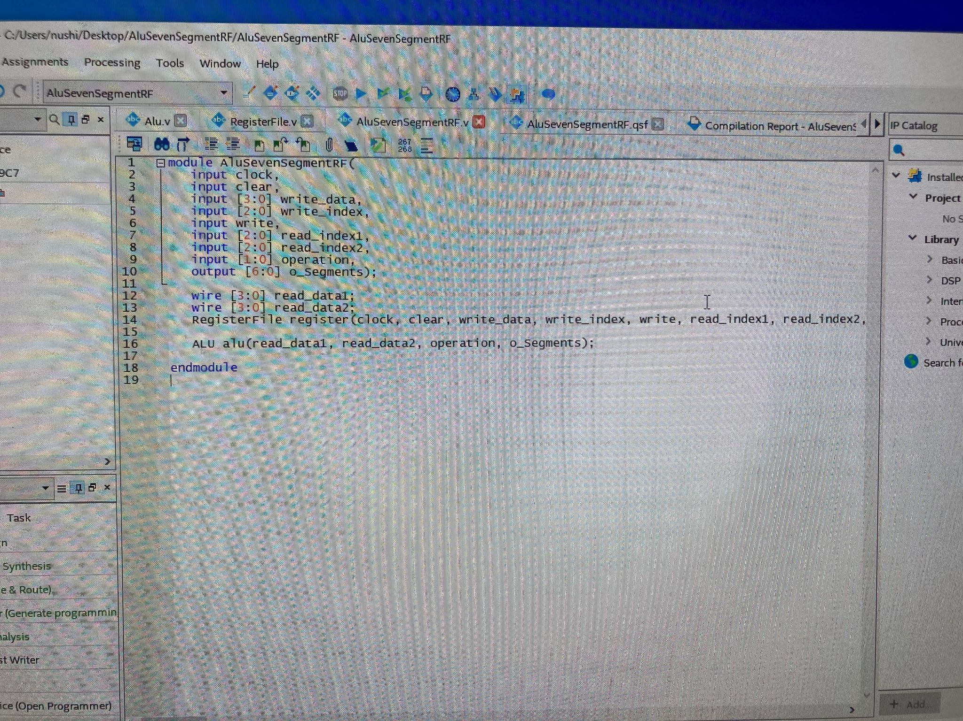

## Output

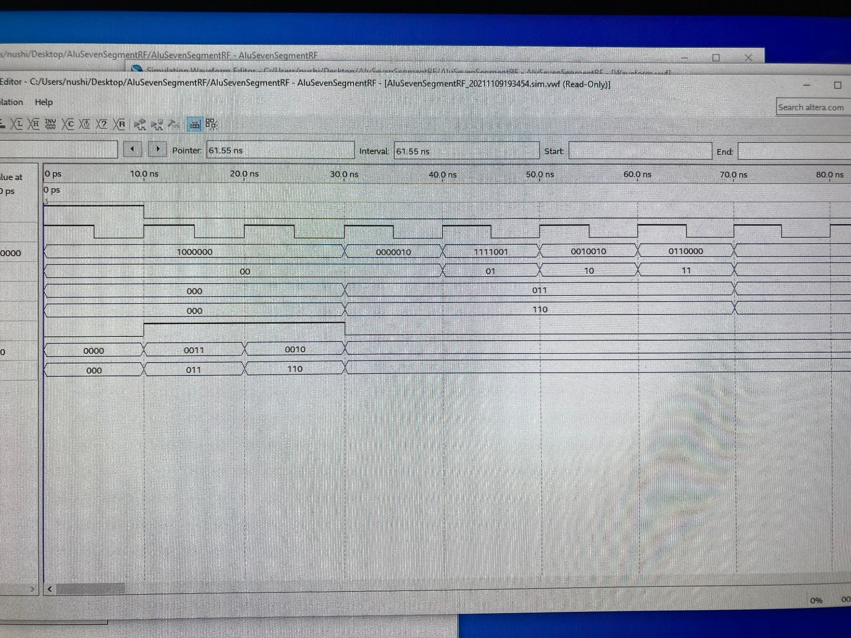

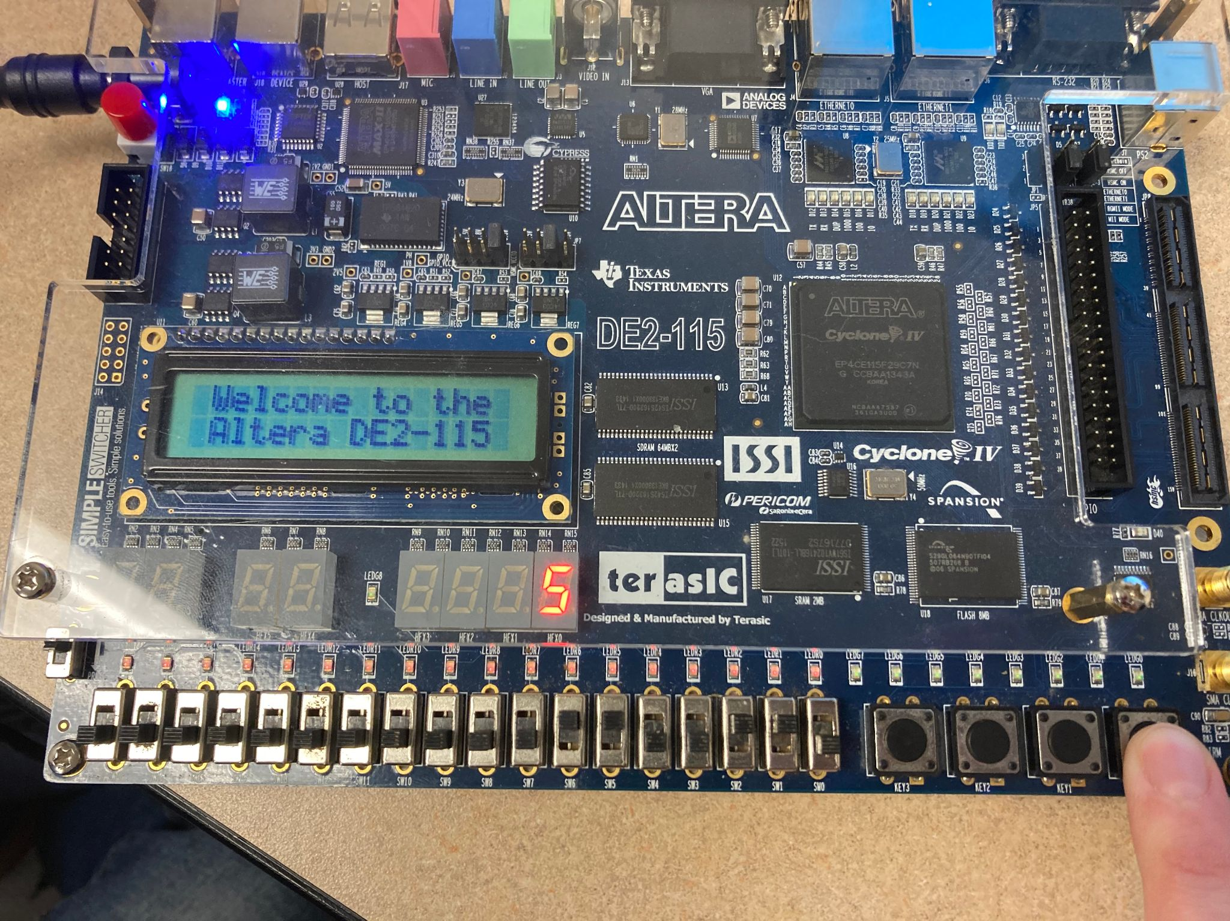

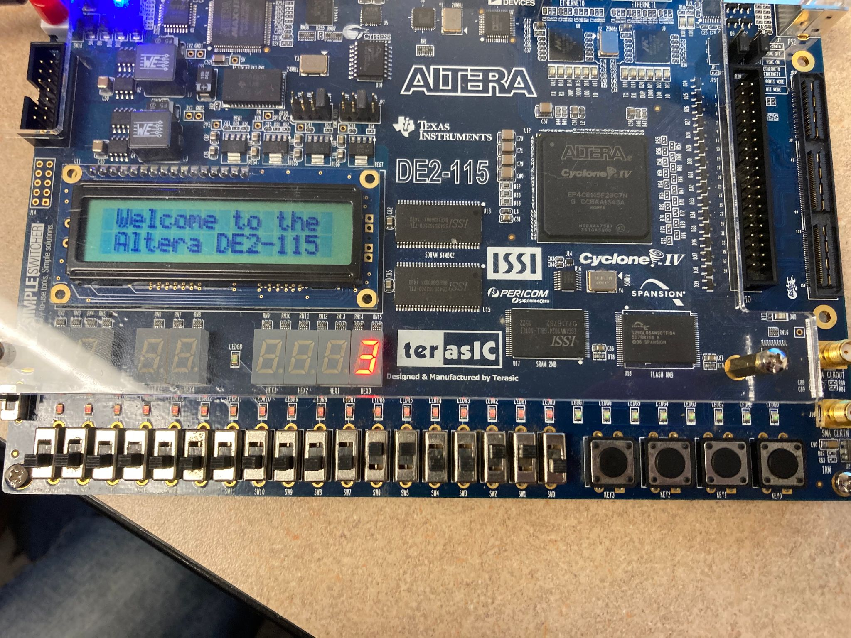

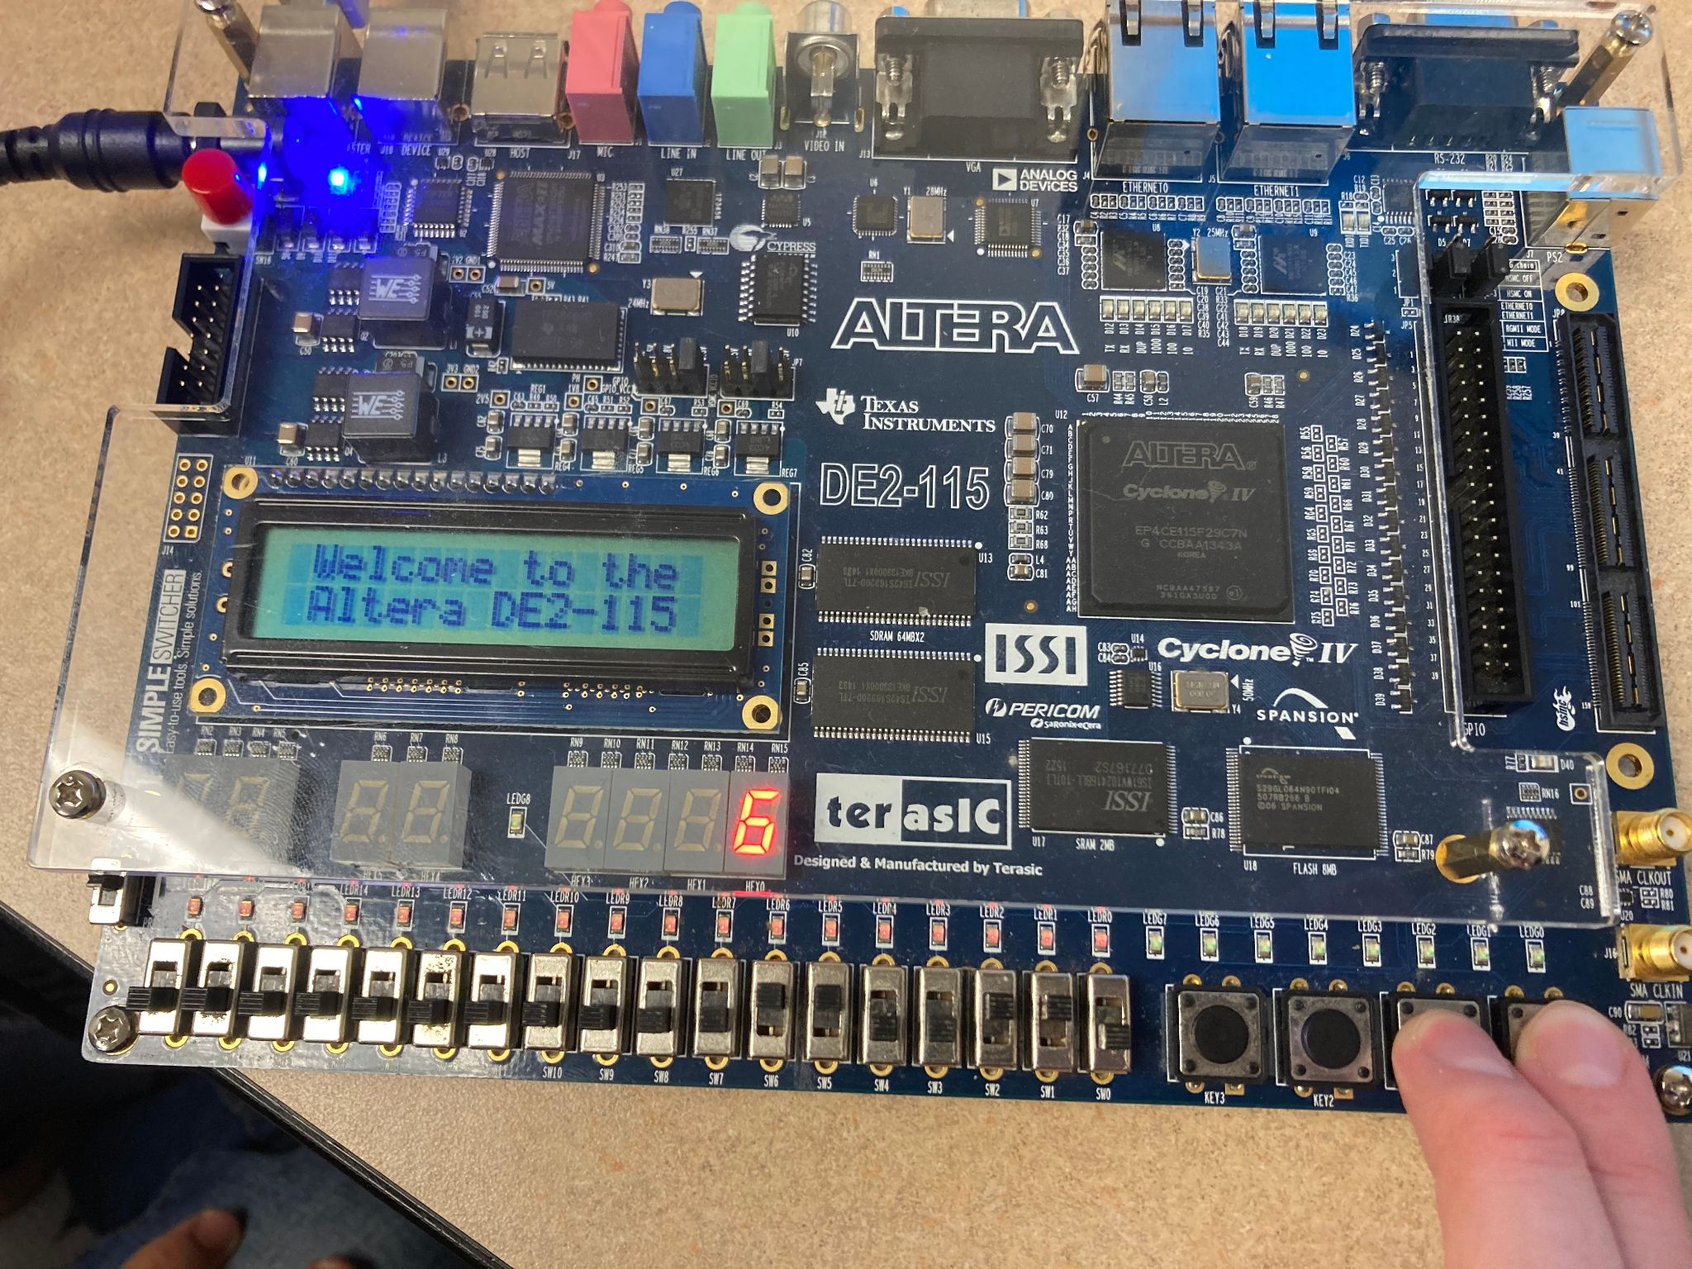

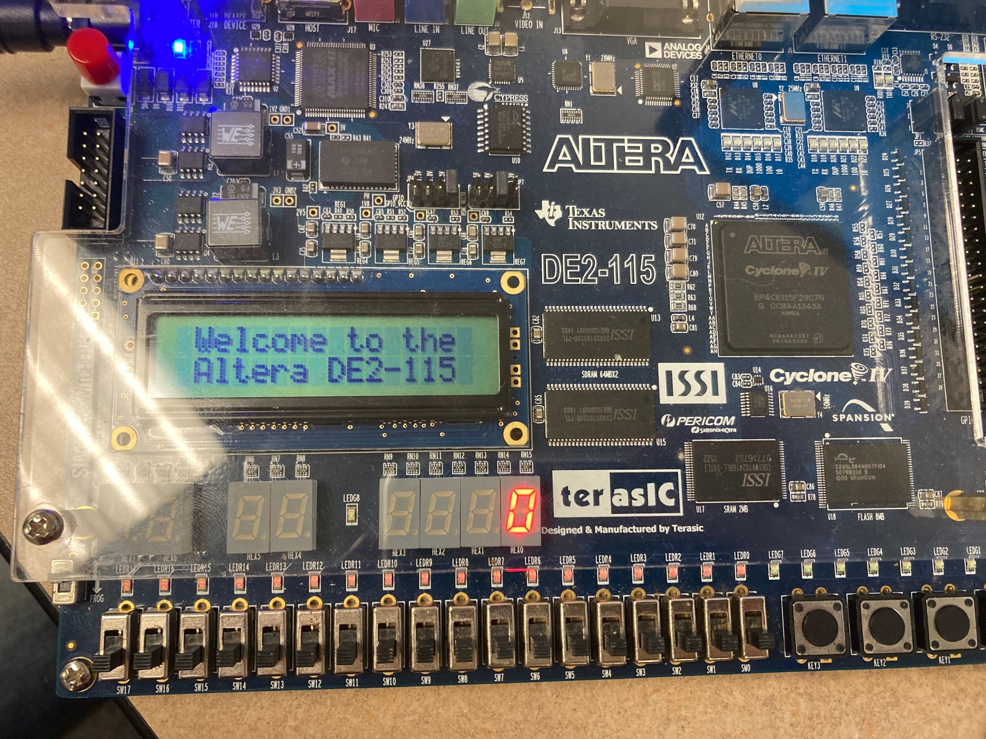

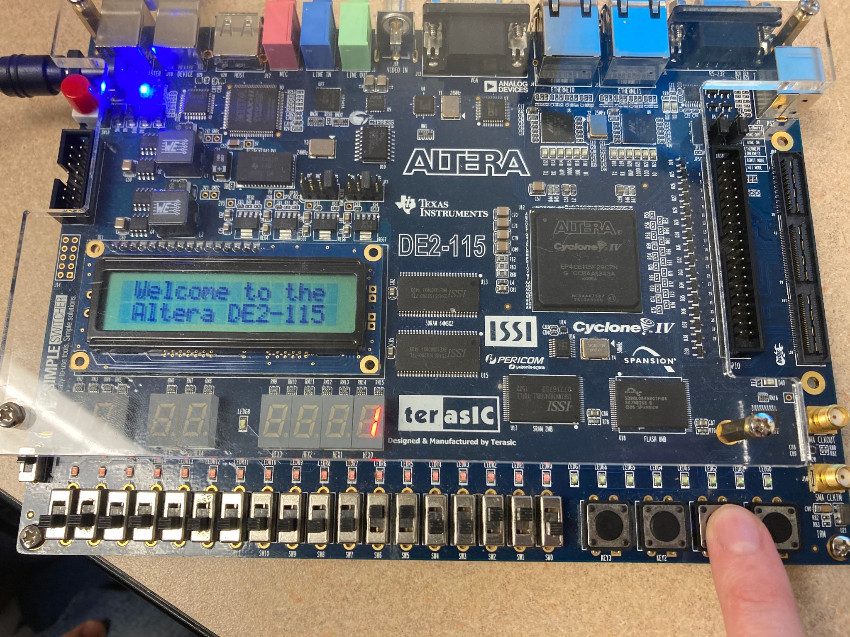

Reflections

1. What did you learn from this lab?

We learned how to combine the ALU and register modules in order to perform arithmetic operations and display numbers on the Altera board.

1. What errors did you face and explain how you resolved them? Feel free to collect screenshots of errors or copy and paste them here?

We had some trouble with getting our code to compile, which required us to review some syntax errors. We also had trouble obtaining the correct waveform which required us to correct the bit notations in SevenSegmentDecoder.

1. What tasks did each of you perform in the lab? You can say we both did everything together or if you divided tasks amongst yourself or some other way that you used to accomplish this lab?

Jonathan - Reviewed the verilog code, checked over pin assignments and waveform bits

Grace - Copied over the code from our previous labs as well as making necessary modifications for this lab and entered the waveform bits

1. What reference material did you use for this lab? If it was a resource from the web, please include it here.

We used the lab guide, the pin assignments provided, as well as repurposed code from labs 5 and 6. Specifically, the code that we used for Alu.v and Registerfile.v.